**测试文档**

**测试用sql语句**

1. **create** **database** he;
2. use he;
3. **create** **table** student    (
4. id **varchar**(20) not null **primary** **key**,
5. **name** **varchar**(6) null,
6. gender **varchar**(2)
7. );
9. **insert** **into** student(id, **name**) **values**("asd","dsa");
10. **insert** **into** student(id, **name**,gender) **values**("he1","bo1","tao1");
11. **insert** **into** student(id, **name**,gender) **values**("he2","bo2","tao2");
12. **insert** **into** student(id, **name**,gender) **values**("shi","a123","a555");
13. **insert** **into** student(id, **name**,gender) **values**("he3","bo2","tao2");
14. **insert** **into** student(id, **name**,gender) **values**("he4","bo2","tao2");
15. **insert** **into** student(id, **name**,gender) **values**("shi2","a1231","a555");
17. **select** id,**name**,gender
18. **from** student;
20. **select** id,**name**,gender
21. **from** student
22. **where** id="he1";
24. **update** student
25. **set** **name**="hebotao"
26. **where** id="he1";
28. **select** id,**name**,gender
29. **from** student
30. **where** id="he1";
32. **delete**
33. **from** student
34. **where** **name**="bo2";
36. **select** id,**name**,gender
37. **from** student;
39. **drop** **table** student;
41. **drop** **database** he;
43. **create** **database** bo;
45. use bo;
47. **create** **table** studentHe(
48. id **varchar**(20) not null **primary** **key**,
49. **name** **varchar**(6) null,
50. gender **varchar**(2)
51. );
53. **insert** **into** studentHe(id, **name**,gender) **values**("he1","bo1","tao1");
54. **insert** **into** studentHe(id, **name**,gender) **values**("he3","bo2","tao2");
55. **select** id,**name**,gender
56. **from** studentHe;

**测试结果截图**

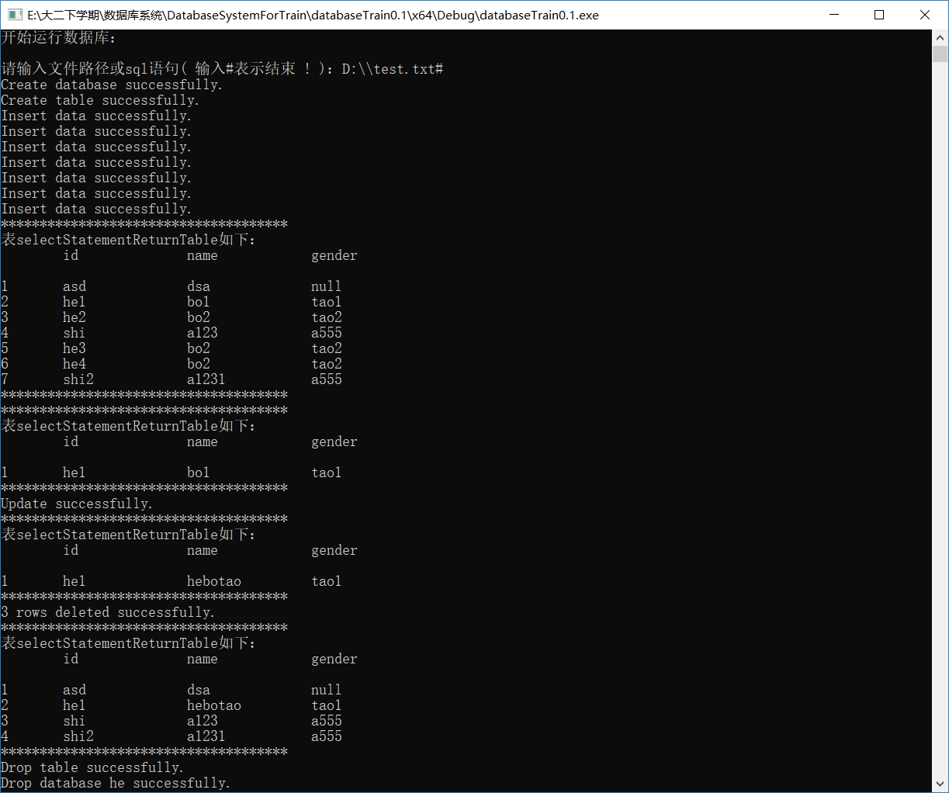

测试结果截图一

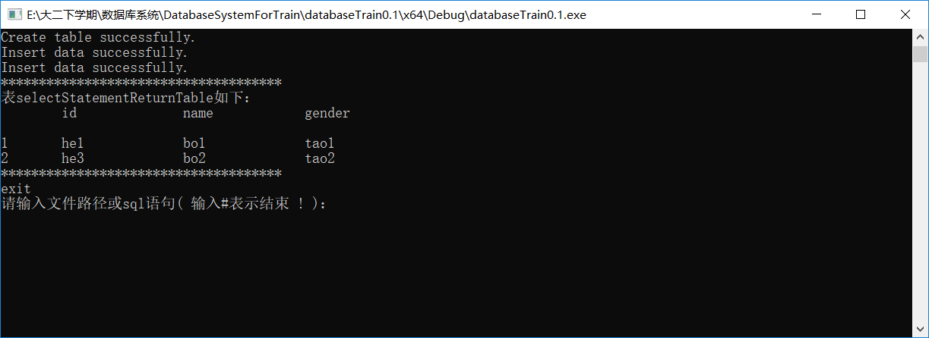

测试结果截图二